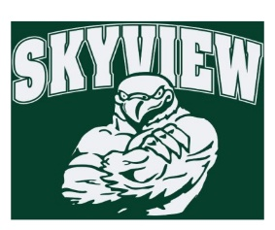
11.05.17 Edition
HAWK HAPPENINGS

Lost and Found – Please remind your student to check out the lost and found in the main lobby. All unclaimed items will be donated at the holidays.
Spirit Wear –Skyview apparel is available for purchase at yourstartingineup.com. All items can be customized with a school logo, your name, and more. Spirit wear makes great holiday gifts while showing your school spirit! All sales benefit your child's school. All items are custom and take 2-3 weeks for delivery! www.yourstartinglineup.com.
Yankee Candle – Our on-line store will be open until January 2018! Yankee makes the best gifts and better yet, Skyview earns 40% of sales. There are three ways to obtain sales: 1.Share the catalog with family and friends 2.Online Sales ‐ set up a seller’s login at www.yankeecandlefundraising.com 3.The New Mobile App – download Yankee Fundraising at Google Play or Apple App Store
Delivery: Week 12/4/17 ~Skyview Group #: 999971230 ~ www.yankeecandlefundraising.com Any questions please contact Courtney Kusy at courtcopp621@gmail.com
Skyview Bowling Club – There is bowling this week, Tuesday, November 14th . Please report to the recess doors at 1st bell.
Boxtops –Congratulations to Ms. Dunn’s 6th grade classroom!
Directory –Student directories will be distributed this week.
Looking Ahead
- Chick-fil-a will host Skyview’s Dine-out all week November 20-25th
- Our last Spirit Night of the year is Friday, November 24th. Join your friends (an opportune time for a Parent’s Night Out!) from 7-10 pm at Skyzone for GLOWZone! Flyers coming home this week! Spirit Nights will resume in February. $4/jumper will be donated towards Skyview’s Home & School Assoc.
Glow Zone sells out quickly. Walk-ins are not advised. Advance purchase tickets on line at: http://oaksstore.skyzone.com/m/area/Info/Glow_Zone
Be sure to sign you on-line waiver and bring this flyer and your Sky Zone socks with you to check in. Sky Zone socks available for purchase $2.50.
No long lines! Sign in at the designated Skyview Fast Pass Lane when you arrive!
This fundraiser is good for any students and family members of Skyview students!!

